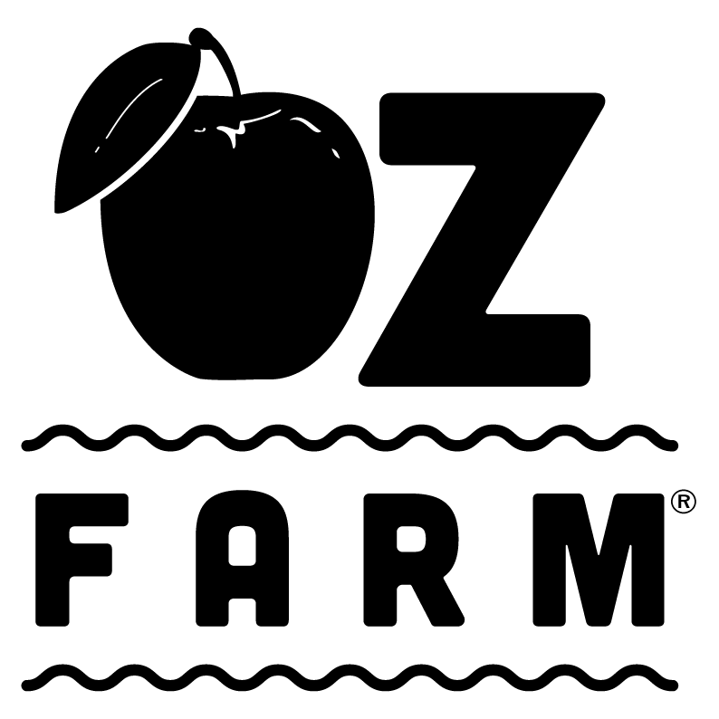

Weddings/ Rental
Agreement

Event Date:
Event Hosts:
Bride's Info:
Name:
Email:
Address:
Phone:
Groom's Info:
Name:
Email:
Address:
Phone:
Function Type / Event Name:
Event Space / Rental Areas (Circle All That Apply): Main Camp, Domes & Barn
Number of overnight guests: ________ Number of day guests: ________

Rental Fees (including applicable surcharges and taxes): $10,000
Deposit Received:
$1,000 Non-refundable Booking Deposit
$1,000 Refundable Cleaning and Damage Deposit
$2,000 Total Deposit Due at Booking

Final Payment for event space rental by ___________ (due 2 weeks before date of Rental): $9,000 Rental Fee
$2,000 Coordinator Fee
Bookings that are not paid in full 2 weeks before the Event Date are subject to a $200 surcharge and/or cancellation. Payments must be made by check or credit card.

Cancellations: The $1,000 booking deposit is non-refundable in the event of cancellation. No refunds of the final payment shall be made if cancellations are made within 2 weeks of the Event Date.
Oz Farm, LLC henceforth referred to as Oz Farm reserves the right to cancel a booking if the Event Space or Rental Areas are rendered unsuitable for use due to fire or other calamity, notice of violations by any city, county or other governmental agency or any other event beyond Oz Farm’s reasonable control. In such an event, Oz Farm will refund all amounts paid by Event Host (including the booking deposit) and/or, if possible, will attempt to reschedule the Event to a mutually agreeable date.

Damage/Return of Cleaning and Damage Deposit: The Event Host is responsible for leaving the Event Space and Rental Areas in the same condition as it is rented, and must remove all equipment, décor and other property brought in from outside sources directly following the Event. The Event Host agrees to pay for any damage caused by the Event Host or any guest, invitee, employee, agent, caterer, vendor of the Event Host. Any damages or cleaning fees will be charged against the $1,000 Cleaning and Damage Deposit; any portion remaining from the Cleaning and Damage Deposit will be refunded within two weeks of the end of the Event. ​The $1000 cleaning deposit is an additional charge to the final payment, only half of the $2000 deposit is deducted from final payment.

Day of Coordinator: The Event Host agrees to use an Oz Farm Day of Coordinator listed on their resources for planners website page. The use of the Day of Coordinator is a mandatory requirement for all wedding parties and must be pre-approved by Oz Farm. This is an additional fee to be paid to Oz Farm two weeks prior to the event date.
Use of Event Space/Rental Areas: The Event Host will conduct the Event in an orderly manner and in full compliance of all applicable laws, ordinances and regulations. Firearms and other weapons are strictly prohibited anywhere on the Oz Farm property.

Inclement Weather: The Event Host assumes all responsibility for inclement weather (such as rain, wind and cold).

Surcharges: Additional fees may be charged for holiday use, excessive power needs (e.g., for extra lights or amplified music), use of a generator, excessive trash, cigarette butts, littering, pets and additional day or overnight guests.

Insurance Requirements: The Event Host must obtain a commercial general liability insurance policy, including host liquor liability, covering the Event, with a minimum coverage of $1,000,000 per occurrence and $1,000,000 aggregate, provided by an insurance company with a minimum A.M. Best’s rating of A-XII, and with Oz Farm, LLC named as additional insureds.

A Certificate of Liability Insurance reflecting this coverage must be provided at least two weeks before the Event Date. A sample of a Certificate of Liability Insurance form and the information required on such form can be found on the Oz Farm website at http://www.ozfarm.com/rates/. If a Certificate of Liability Insurance is not received within two weeks before the start of the Event, Oz Farm reserves the right to charge the Event Host a surcharge of $500 to provide this coverage.

Release and Waiver of Liability Agreement: The Event Host shall be responsible for signing the Release and Waiver of Liability Agreement and resume responsibility for each overnight guest.

Indemnification and Waiver of Claims: The Event Host shall indemnify, defend and hold harmless Oz Farm, LLC and its officers, managers, members, employees, agents, representatives and assigns (the “Indemnified Parties”) from any and all claims, demands, damages, costs or liabilities, including reasonable attorneys fees (collectively, the “Damages”) that may arise during or be caused by or related to the Event or by the use or occupancy of the Oz Farm property by the Event Host or any guest, invitee, employee, agent, caterer, vendor of the Event Host or any other person present on or entering or leaving the Oz Farm property as a result of the Event or the Event Host’s use or occupancy of the Oz Farm property (collectively, the “Event Participants”), including without limitation, Damages caused by the action, inaction or negligence of the Event Host, the Indemnified Parties or others (the “Indemnification”). This Indemnification includes, but is not limited to, Damages related to damage or destruction of property, whether owned by the Event Host, the Event Participants, Oz Farm or others, and any injury or death to any person, except to the extent such Damages result from the gross negligence or willful misconduct of the party seeking the Indemnification.
The Event Host assumes all risk of damage to property or injury or death to persons in or about the Oz Farm property that may arise during or be caused in any way by the Event or by the use or occupancy of the Oz Farm property by the Event Host or any Event Participant. The Event Host releases and waives all claims against the Indemnified Parties for damages to personal property of the Event Host or any Event Participant, and for injury or death to the Event Host or any Event Participant, whether caused by the action, inaction or negligence of Event Host, any of the Indemnified Parties or others.

The Event Host agrees to all the information given and has also thoroughly read through the wedding policy packet, FAQ and wedding pricing details.

Agreed and Signed By:

Event Host(s)

Print Name_________________________ Signature ______________________________

______________
Date

Print Name_________________________ Signature______________________________

______________
Date

Oz Farm, LLC

Signature _________________________ Date ______________

